**Andrew H Rodgers Ph.D. Certified Industrial Hygienist (CIH)**

Andrew Rodgers has over 20 years’ experience in environmental and safety matters.

Environmental experience includes hazardous and solid waste and multimedia permitting.

Safety and Health experience include multimedia audits at Academic and Industrial facilities.

Building Science is a forte performing building lead (has X-ray lead detecting device) asbestos and mold inspections and remediation plans.

Remediation plans are another forte as a licensed contractor in asbestos lead and mold remediation in Louisiana.

My Ph.D. is in Analytical Chemistry so I can professionally interface with Industrial Hygiene and Environmental Testing Laboratories as to Client needs.

Outside of consulting I enjoy gardening, raising grandchildren and visiting my UK family in England.

The profile picture is old, but it shows me with LA Governor Foster and LA DEQ Secretary Dale Givens receiving an industrial wastewater minimization award by reducing wastewater discharge to the facility 7000 feet deep wastewater injection wells.

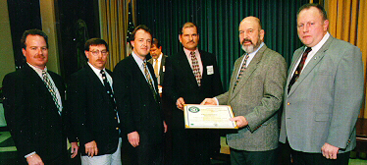

(Rodgers 3 rd. from left, Governor Foster 5th, LADEQ Secretary Givens far right)